Catholic Junior College
JC2 Preliminary Examination
Higher 2



Instruction

GEOGRAPHY 9173/02
Paper 2 15 September 2026
INSERT
3 hours

READ THESE INSTRUCTIONS FIRST
This Insert contains all the resources referred to in the questions.

This document consists of 8 printed pages and 2 blank pages.
Resource 1 for Question 1
Background Information on Giao Lạc
Giao Lạc is a coastal village in the Red River Delta’s Giao Thủy District, where the river meets the sea. Rising sea levels and severe typhoons cause regular flooding, introducing salt into the soil and destroying rice crops. To protect homes, the community manages a 3-kilometre concrete coastal flood barrier and a 500-hectare mangrove forest buffer. The local government monitors these changes using historical weather station data and regional population census logs.
During storms, local volunteers broadcast loudspeaker warnings and guide families along narrow, unlit coastal paths to emergency shelters. The village has about 10,000 residents, with many elderly people and young children because working-age adults migrate to cities for work. The primary economic activities are small-scale, traditional rice farming and family-run aquaculture, such as privately owned shrimp and clam ponds.

Resource 2 for Question 1
Resource 2A
Small grocery shop where students conducted the focus group discussion
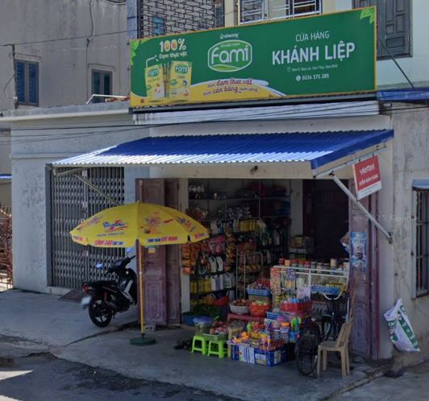

Resource 2B

Site A for environmental survey

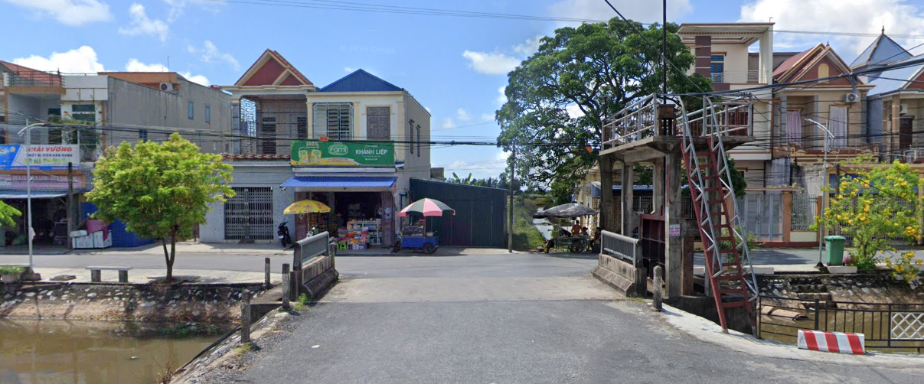

Resource 2C

Site B for environmental survey

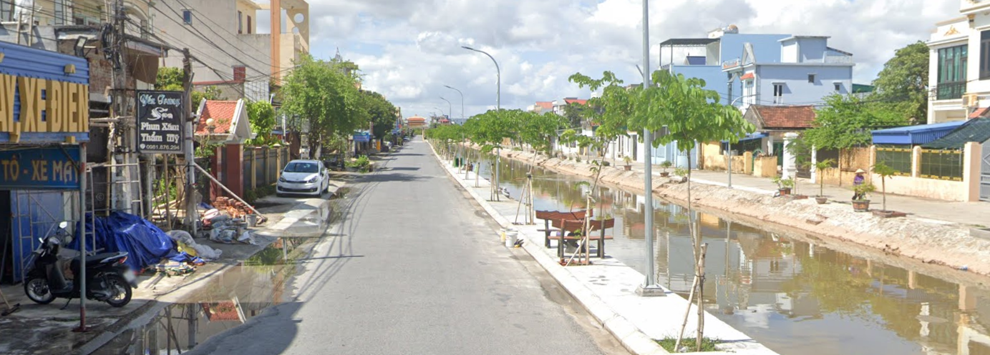
Resource 3 for Question 1

Results of focus group discussion
Question | Number of residents responding positively | Number of residents responding negatively | Selected resident quotes
Have you experienced flooding in your home in the past five years? | 7 | 1 | "The water came into my house three times last year. It is getting worse."
Do you know the evacuation route from your home to the nearest emergency shelter? | 3 | 5 | "I would just follow my neighbours. I don't know the official route, especially at night."
Do you keep emergency supplies at home such as food, water, or a first aid kit? | 2 | 6 | "We cannot afford to keep supplies stored away. We need what we have every day."
Do you trust the flood warnings issued by local authorities? | 4 | 4 | "Sometimes the warnings come too late. By the time we hear the loudspeaker the water is already rising."
Has anyone in your household received formal training in flood emergency procedures? | 1 | 7 | "Nobody has ever taught us what to do. We just do what we did last time."

Resource 4 for Question 1
Environmental survey checklist completed by the students

Flood preparedness indicator | Site A | Site B
Flood warning signs or notices displayed publicly | ✗ | ✗
Evacuation route markers | ✗ | ✗
Drainage channels alongside roads | ✓ | ~
Evidence of raised floor levels or elevated doorsteps | ~ | ✗
Properties with observable water staining or flood damage marks | ✓ | ✓
Roads and pathways free of obstructions for evacuation | ~ | ✗

Ratings: ✓ Observed, ~ Partially Observed, ✗ Not Observed
Resource 5 for Question 2
Photograph of a slum in Asia
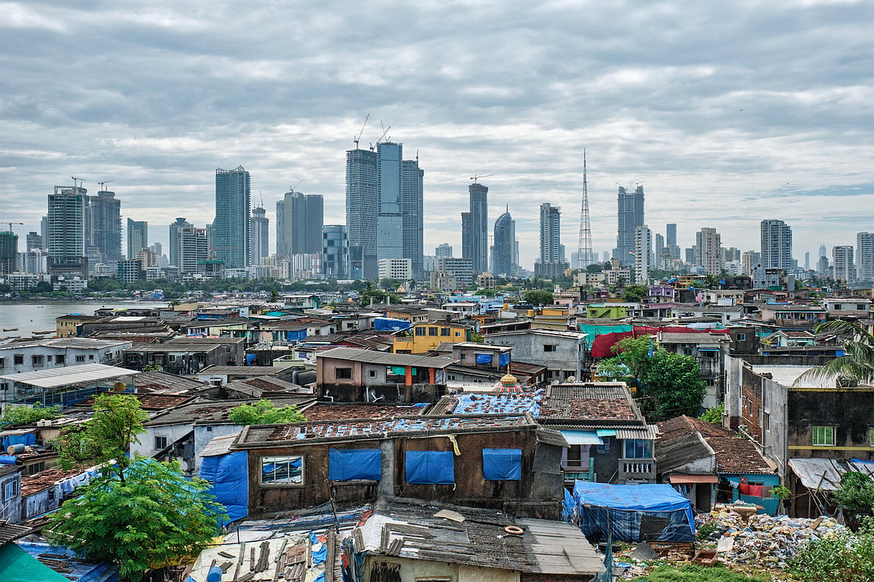

Resource 6 for Question 2

Map of major cities affected by changing climate in the next 50 years
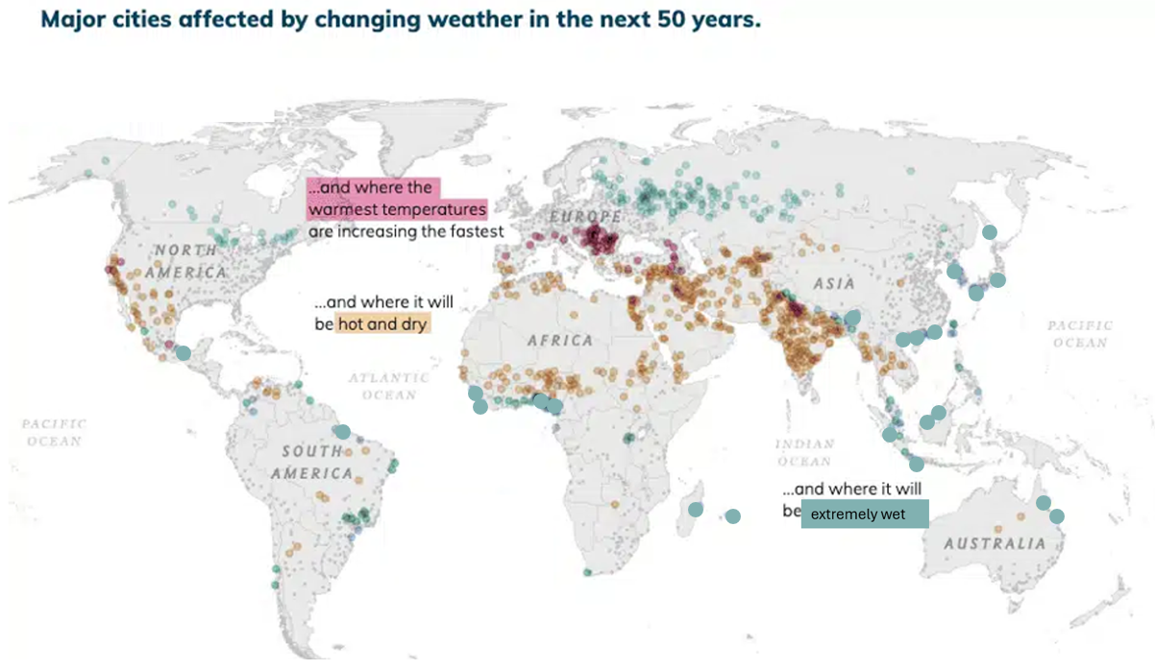
 |  |  | Cities where it will be extremely wet
 | Cities where the warmest temperatures are increasing the fastest |  | Cities where it will be hot and dry

Resource 7 for Question 2
Global cities and their environmental risk
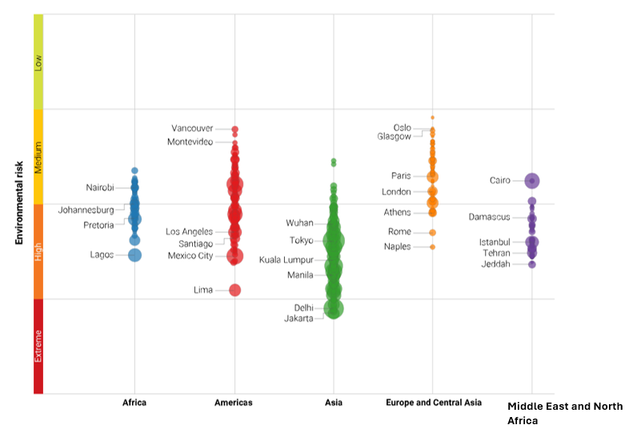
- Environmental risk is calculated using climate change impact, air and water pollution, natural hazards e.g. flooding and more.
BLANK PAGE

Resources
Question 2 Resource 5 [Source: https://www.downtoearth.org.in/urbanisation/why-millions-go-unaccounted-for-in-indias-invisible-slum-crisis]
Question 2 Resource 6 [Adapted from: https://mixedmigration.org/publications/mmr/2020/climate-exposure-the-complex-interplay-between-cities-climate-change-and-mixed-migration/]
Question 2 Resource 7 [Source: https://www.maplecroft.com/insights/analysis/2021/ero-2021/asian-cities-in-eye-of-environmental-storm-global-ranking/]

BLANK PAGE

